GERMAN MOBILIE ISSUES

- Total Skiing is English and km NOT KM – capital and non-capital letters
Also, please fix the other issue one line (!)

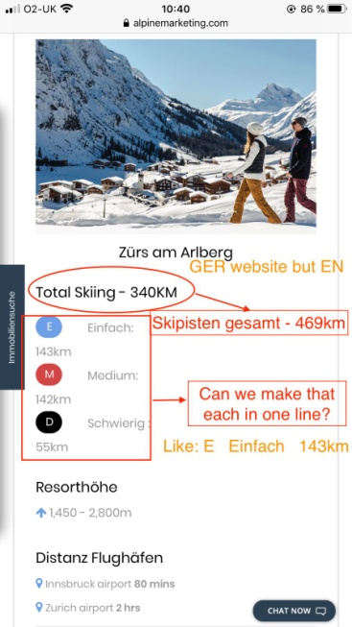

Ck Comments 06-03-2020: We have fixed this issue.
Please check and let us know.NO
Ck Comments 09-03-2020: We have facing issue after activate " Advanced Custom Fields Multilingual" plugin.
Working on it "Total Skilling" word translation issue.

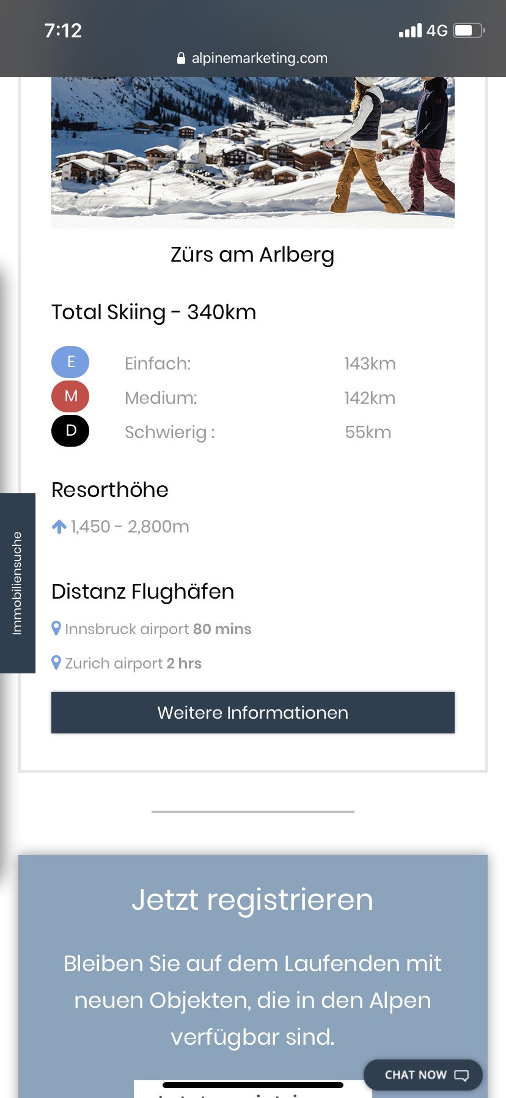

- Please delete empty space here! EN, GER and DUTCH website
- Also: the bullet points should have exactly the same size
- And can you try to put each bullet point’s text in one line
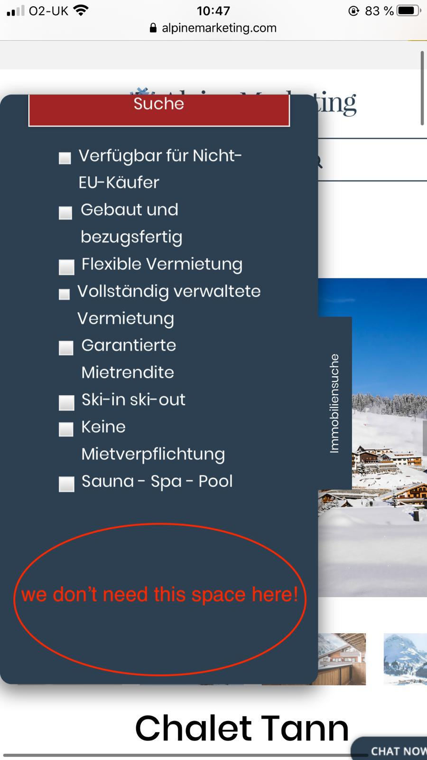

Ck Comments 06-03-2020: We have removed this extra space.
Please check and let us know.YES

- Please can you replace the below red bar with:

also here the link https://www.alpinemarketing.com/de/verkauf-ihrer-immobilie/

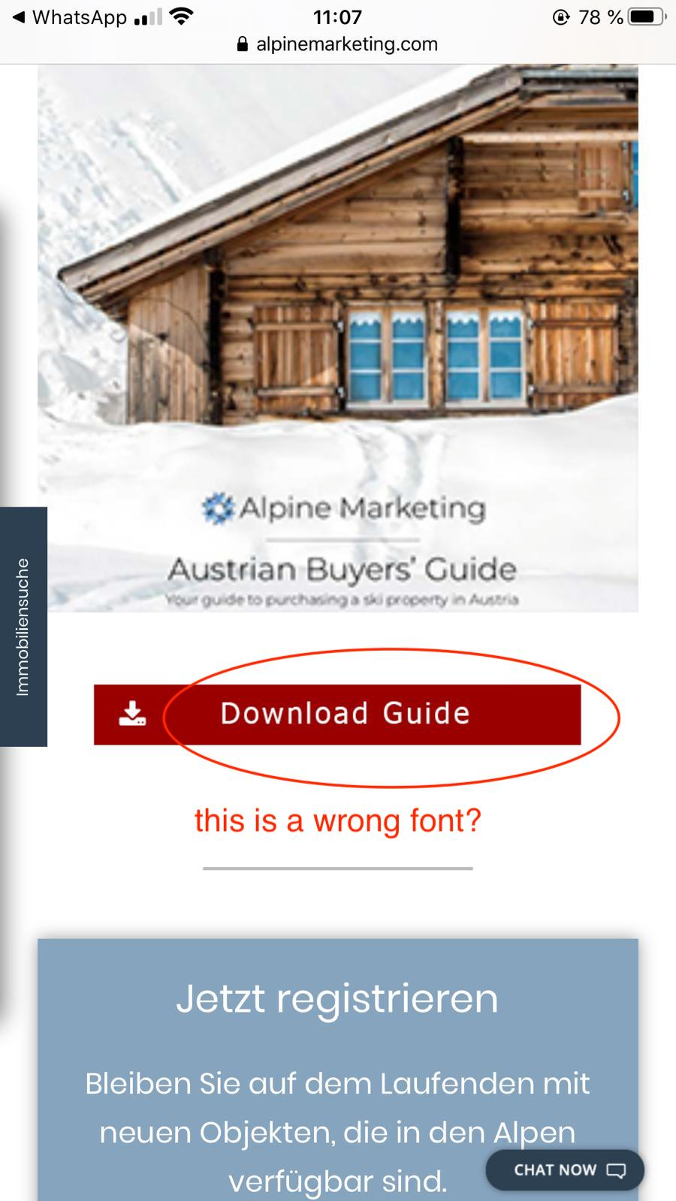

Ck Comments 06-03-2020: Working on it.
Ck Comments 09-03-2020: We have updated download pdf image on FAQ page.
Please check and let us know.
We need high resolution image.

- ALL 3 language websites: The blog posts (below News) on the website looks confusing. The pictures have to match the text and the link to carry on reading.
Please fix the order: 1. Picture
2. Text
3. (Link) / Weiterlesen
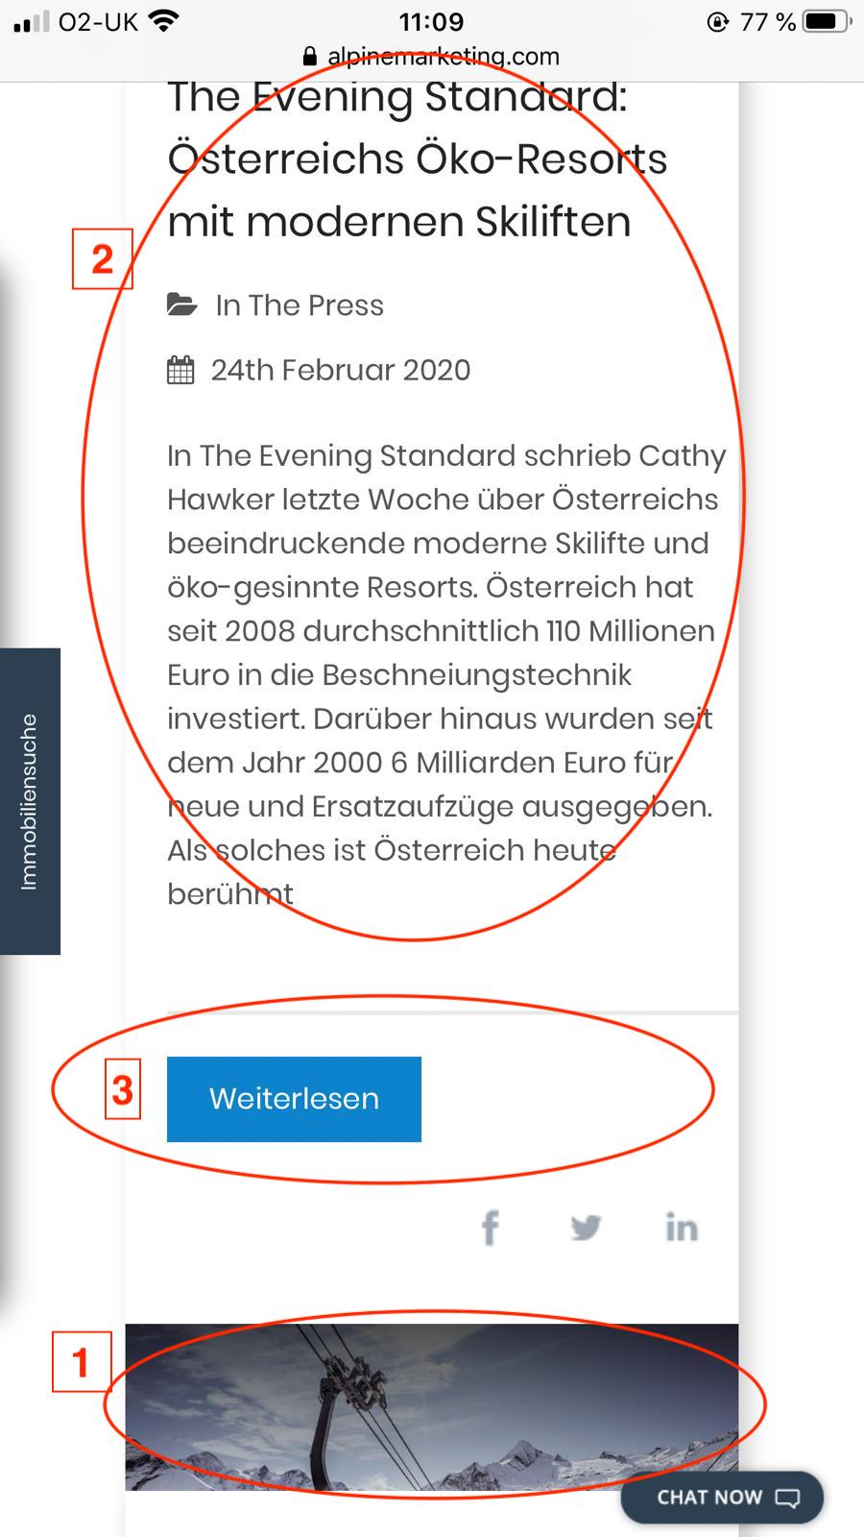
Ck Comments 06-03-2020: We have mange order as mention above.
Please check and let us know.YES

- Please delete this long white bar, only the X with a smaller white background is enough (like on ENGLISH website) Issue on DUTCH and GER website!
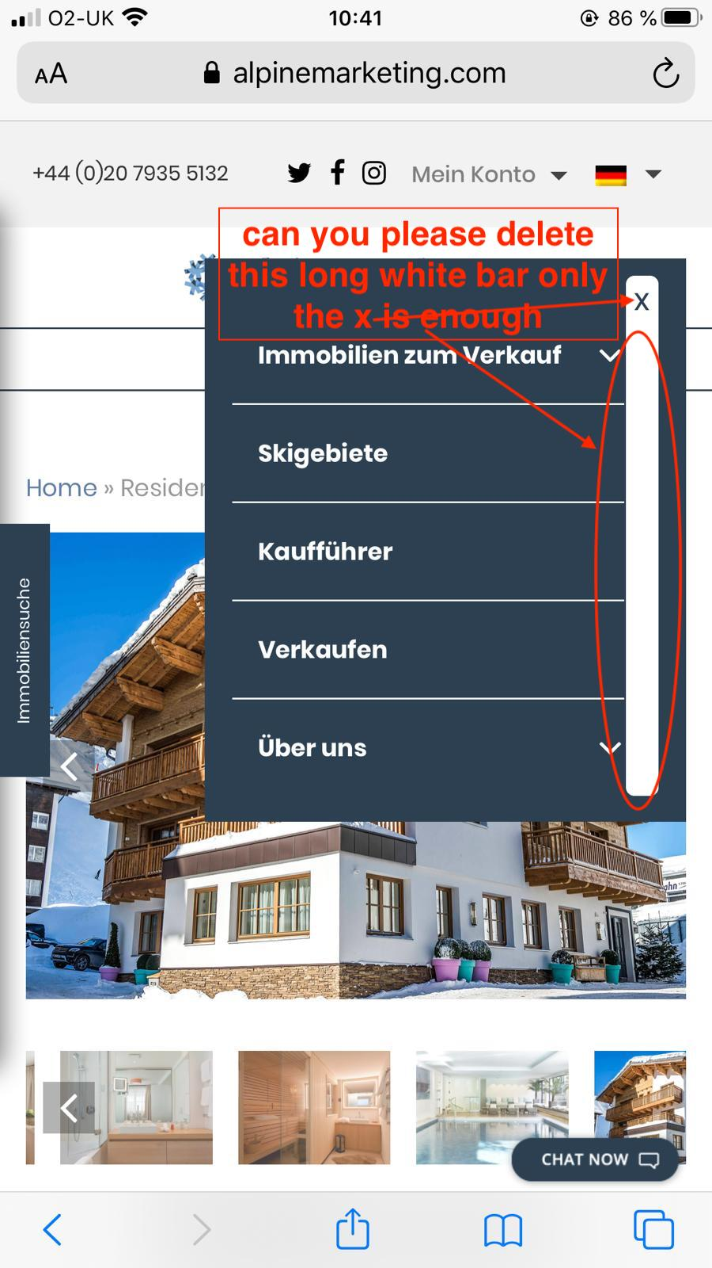
Ck Comments 06-03-2020: We have fixed this issue.
Please check and let us know.YES

- Please make sure everything is in one line issue on EN, GER and DUTCH website!
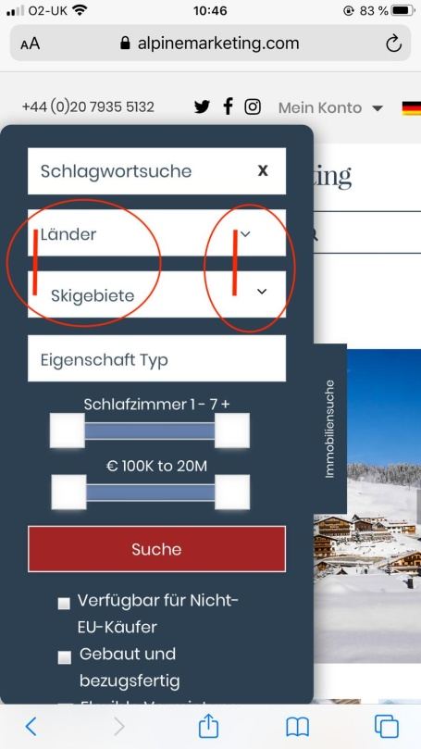

Ck Comments 06-03-2020: We have fixed this issue.
Please check and let us know.NO (before ski resorts still space – all 3 languages!)
Ck Comments 09-03-2020: We have fixed this issue.
Please check and let us know.
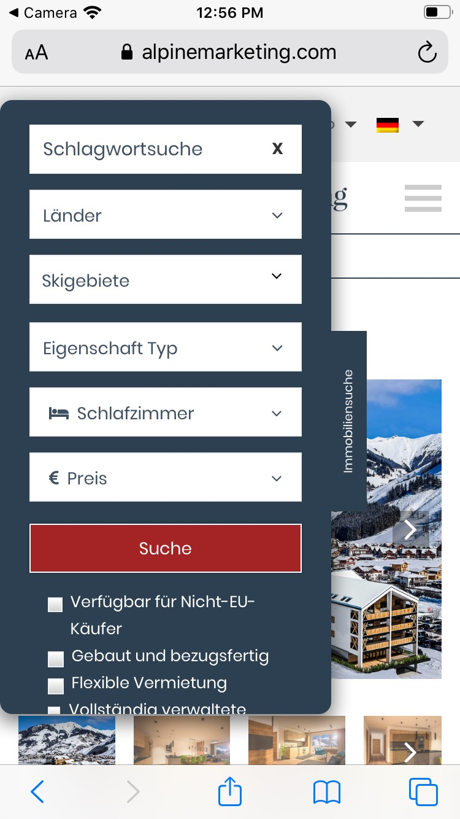

- Similar issue, please make sure everything here is aligned!
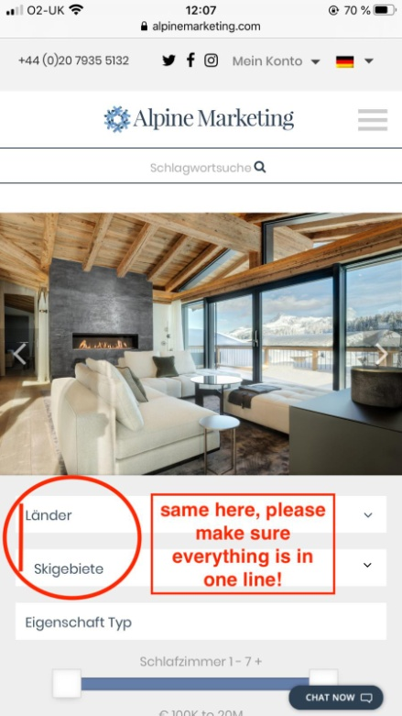

Ck Comments 06-03-2020: We have fixed this issue.
Please check and let us know.NO (still too big space before Skigebiete – all 3 languages)
Ck Comments 09-03-2020: We have fixed this issue.
Please check and let us know.

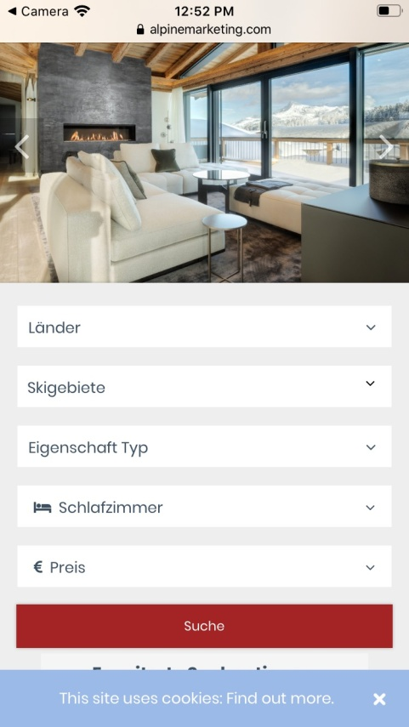

- Available Properties is ENG, please change it to ‘VerfügbareImmobilien’
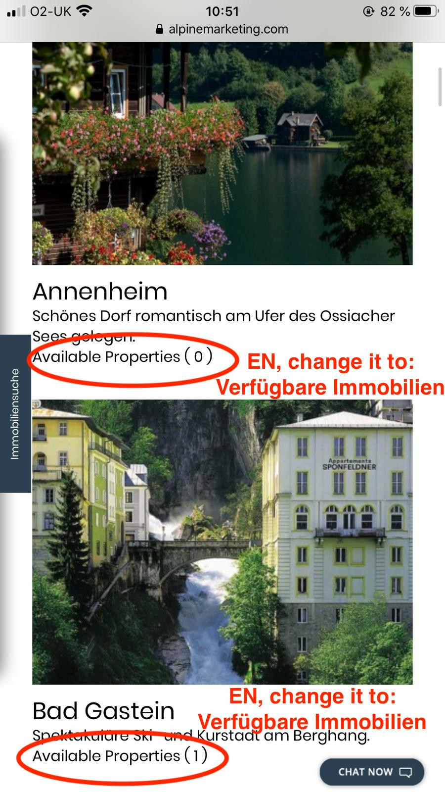
Ck Comments 06-03-2020: We have fixed this issue.
Please check and let us know.HALF, but no ‘ afterImmobilien, please delete ‘
Ck Comments 09-03-2020: We have removed "`" after Immobilien.
Please check and let us know.

- Some boxes are too small, others too big. Boxes, arrows and text must align
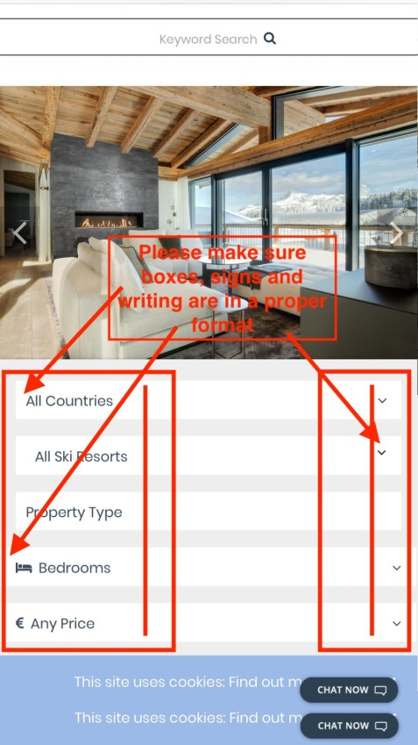

Ck Comments 06-03-2020: We have fixed this issue.
Please check and let us know.NO! Bedroom white bar is fixed, but any price bar no! Also, there is still a space before all ski resorts!!
Ck Comments 09-03-2020: We have fixed this issue.
Please check and let us know.
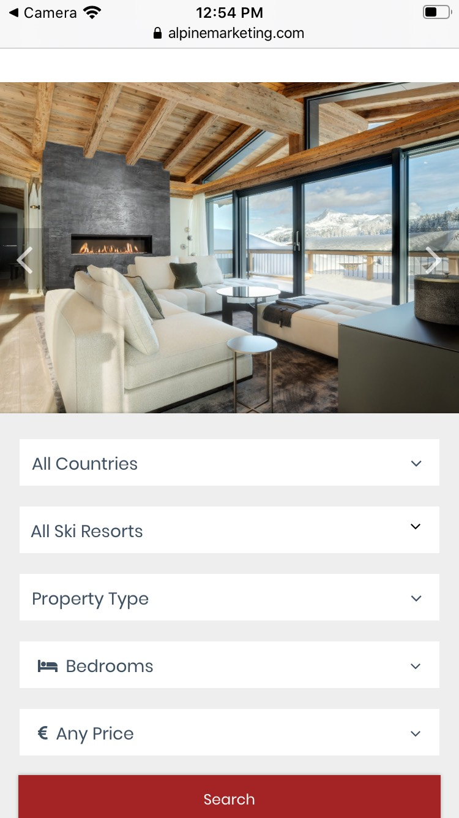

- Also, the English version is updated (screenshot 10!), GER and ENG still old, please make sure there are five white bars and everything is in the same size and properly (no wrong spaces etc)

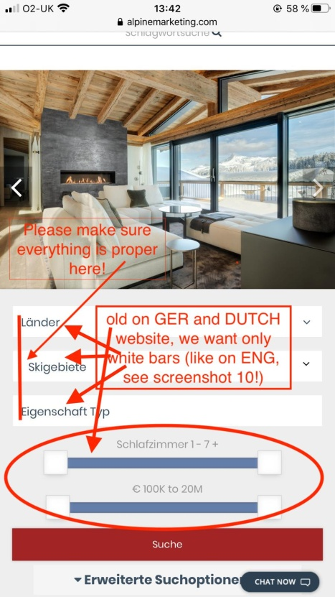
Ck Comments 06-03-2020: We have fixed this issue.
Please check and let us know.NO, GER and DUT still have blue bars and there are still spaces (before Skigebiete)
Ck Comments 09-03-2020: We have fixed this issue.
Please check and let us know.
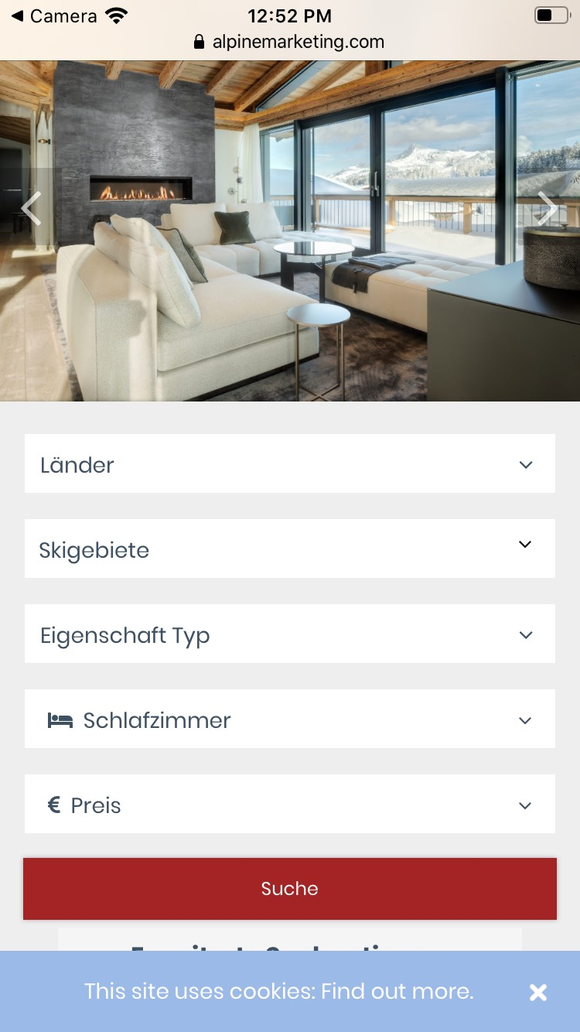

- Please can you delete here the white tight bars, we want everything to be perfect and unique ISSUE on GER, ENG and DUTCH website
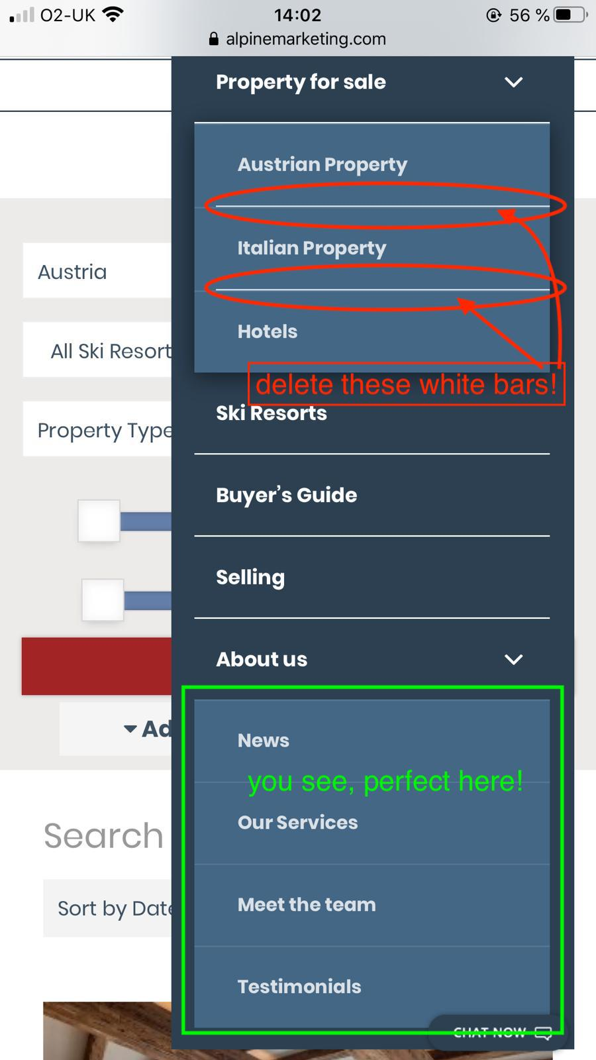
Ck Comments 06-03-2020: we have fixed this issue.
Please check and let us know.YES

- This is Kaiser Lodge in Mittersill, at the very end text after ‘Denken Sie an eineBesichtigung?’ there is an issue, only here, not for the other properties. DELETE:entfernt,,

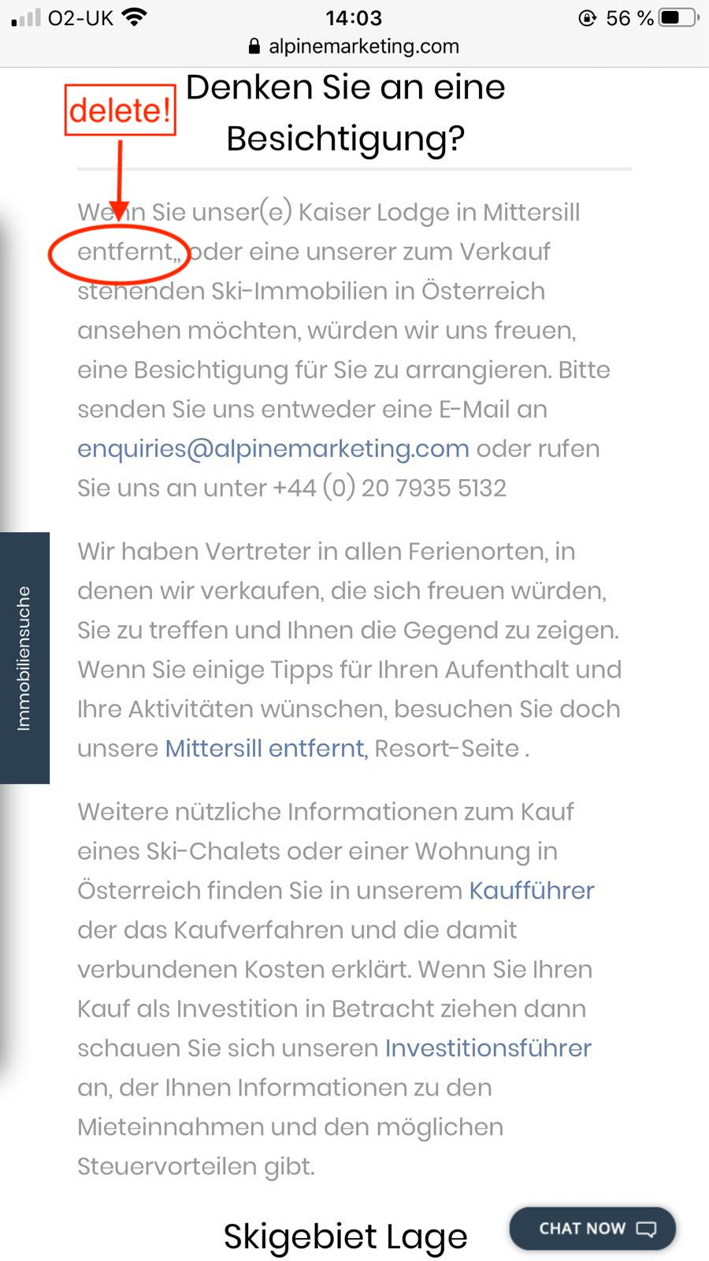
Ck Comments 06-03-2020: Working on itok
Ck Comments 09-03-2020: We have removed "entfernt".
Please check and let us know.

