ALL THE DETAILS ON THE RECENT MLB EXPANSION | EXCLUSIVE NEWS TODAY
THE
OUTRIGHT NEWS

The MLB Complete the… HIGH POINT Heist!

First and foremost, it is an undeniable achievement to have built such an aesthetically pleasing stadium, in an under-developed area. This is truly ground-breaking. A staggering $150m project, which is rumoured to be more due to unforeseen circumstances in the process, brings a beacon of light and hope for the up and coming city of High Point. In an exclusive interview with the team’s head coach he stated “this is what it’s all about, local and state governments working alongside city councils to support sporting projects like so, benefitting the people of the city through pride, employment and diversity. When they ask where some of their tax goes to, here is a physical representation of those hard-earned contributions”. There comments reflect just how important this move is for baseball but also society today. | 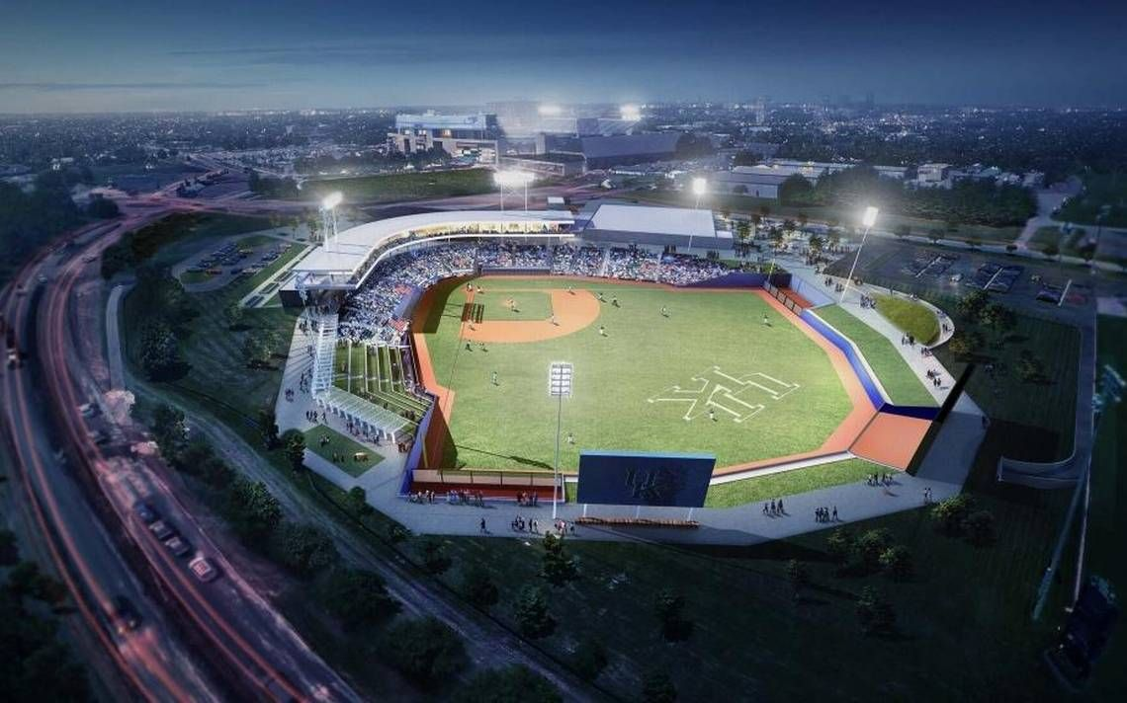  The enormous stadium consists of 3 stands with back seating and plenty of leg room, several concessions stands, 5 VIP box rooms with luxury leather seating and personal waitresses to serve the 3 course meals and plenty TV screens highlighting various angles of the park. Additionally, in honour of Oak Hollow Lake (which isn’t too far from the stadium) the colour of the fencing is light blue, this brings a light and attractive touch to the exterior of the grounds. After much speculation and doubts, I believe it is fair to say, they are done an incredible job with this state-of-the-art stadium design!  Sport investor Austin Cook claims that “the expansion could have detrimental effects to its reputation”, but this is largely disregarded because it shows a growth mentality and aim to expand its horizons for 2020.
As a sport economist myself, it was a genius move to have this construction in High Point because the city had so much potential for growth and now that has been fulfilled. Local businesses will reap the benefits of more and diverse customers, increasing sales and profitability. Unemployment will reduce and potentially crime as well, because teenagers have a sporting team to support and visit, spending their time more productively rather than lazing around the streets. Nevertheless, not everybody has the same opinion…
Written by: Jean-Luc Ramdin
The Outright News ltd.

